RESOLUTION NO.__________

RE: CERTIFICATE OF APPROPRIATENESS UNDER THE
PROVISIONS OF THE ACT OF THE PENNSYLVANIA
LEGISLATURE 1961, JUNE 13, P.L. 282 (53
SECTION 8004) AND BETHLEHEM ORDINANCE NO.
3952 AS AMENDED.

WHEREAS, it is proposed to install a sign at 119 E Third Street.

NOW, THEREFORE, BE IT RESOLVED by the Council of the City of Bethlehem that a Certificate of Appropriateness is hereby granted for the work.

Sponsored by: (s)

(s)

ADOPTED BY COUNCIL THIS DAY OF

(s)
President of Council

ATTEST:

(s)
City Clerk

HISTORIC CONSERVATION COMMISSION

CASE # 559 – It is proposed to install a sign at 119 E Third Street
OWNER/APPLICANT: East Allen Venture LLC/ Wen Zhu Zhou

The Commission upon motion by Mr. Cornish seconded by Mr. Loush adopted the proposal that City Council issue a Certificate of Appropriateness for the proposed work described herein:
- The proposal to install a sign at 119 E Third Street was presented by David Delos Santos.
- The new sign will fit within the panel molding on the sign fascia of the storefront and be approximately 3’ x 10’ in size. The sign will read “U&TEA” in red lettering and “Authentic Chinese Food” in black lettering on an off-white or bone background with a Chinese symbol to the left. A pinstripe border or borders will be added in red or black.
- The sign will be 3/4” solid PVC material.
- The proposed motion was unanimously approved.

CU: cu
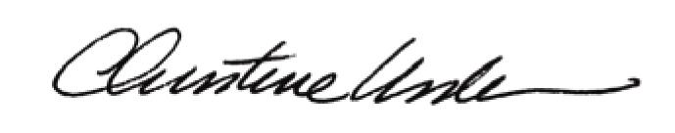

By:

Date of Meeting: July 20, 2015 Title: Historic Officer

